**《软件项目组织与管理》课程作业**

**班级：14011907**

**学号：2019302789**

**姓名：梁芮槐**

# Chapter 9

## 9.1 Practice 1

**【Answer】**

<https://www.youtube.com/watch?v=_OXKszvJE00>

Google's Human Resources Management has established a corporate culture centered around employee approval. The HR division is Google's strategic partner, with a focus on helping the company run its core business by hiring and retaining the best employees. She likes abilities more than experience and only hires the smartest people. These are the human resource management practices that Google is different from the competition. The most obvious thing for tech giants is to implement a combination of wages and benefits to keep employees motivated. Google, like search engines and other IT products, is increasingly known around the world for its employee-friendly environment and policies. As the best employer, she pays great attention to human resource management. Google employees believe that their office life is fulfilling and happy. Google didn't achieve its business goals with strict controls like Apple, but on the contrary, she's enough to develop their talents for all employees and do their best to realize their value. Gave room. In this respect, she maintains a higher level of transparency (using OKR) than other organizations. She also uses technology to improve her performance. The focus of Google's talent strategy is to provide maximum care and support to help employees perform their jobs. The benefits that Google offers to its employees are in awe in the industry. In addition to job safety, Google's high risk-return rate also guarantees job satisfaction. At the same time, a well-designed training and performance management system ensures that everyone receives the right guidance and support. Recruiters focus on hiring talented and culturally compatible employees. Culture plays an important role in recruiting new employees. Cultural compatibility with Google will improve your performance when you join Google. The role of culture and cultural compatibility has also been proven by research. Culturally compatible employees mean that your organization is more productive overall.

Another focus of Google's recruitment strategy is diversification. We have worked with several organizations to make the hiring process successful and bring a very diverse workforce. Diversity isn't just about talent, it's about every aspect of Google's business. "Google doesn't always exist, so we're always looking for someone who can bring new perspectives and life experiences to our team," Google himself said. Google's human resources department has to take heavy responsibilities, so its size is also above average. Google emphasizes fairness at all stages, from recruitment to performance management, and provides all employees with fair growth and growth opportunities. High performance, high profit, low performance, low profit. Google rewards are also based on performance plans. Google Peer feedback is used to evaluate performance, allowing evaluators to select colleagues from across the organization to report on their performance. Not only is she your boss, but your subordinates can also be part of your evaluation team. Therefore, employees must do their best to reach their goals. The customer-supplier relationship is a cooperative relationship and does not mean that everyone can ask for it. A wise company considers a supplier as important as a customer and, as he knows, behaves very politely and politely everywhere. Only by treating the suppliers in the same manner will the suppliers do their best to make the best products for them and have the potential for the entire market.

## 9.2 Practice 3

**【Answer】**

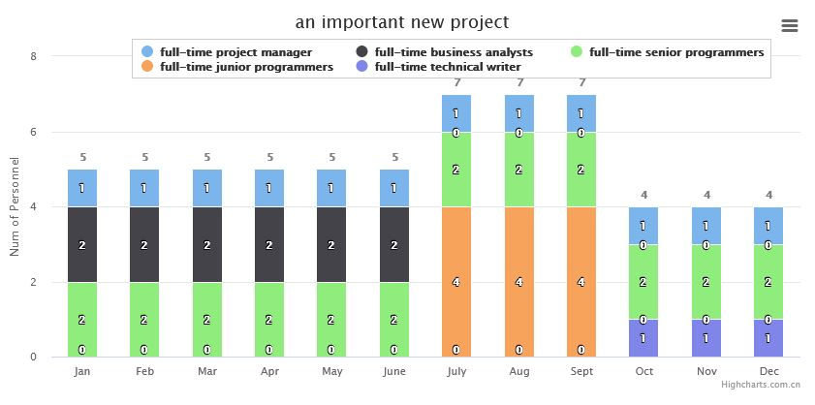

## 9.3 Practice 4

**【Answer】**

My personality type tends to be "ISTJ" (Introverted, Realistic, Thinking, Judgment, Tendency: I65, S56, T91, J88, Thoughtless Index: 20)

I belong to the "traditionalist", the following is a description of the "traditionalist":

"Traditionalists" believe in facts, verified data, past experience, and the information brought to them by the "five senses". They like a structured world and make decisions. They are a person who is realistic and has clear goals.

"Traditionalists" are the most traditional type of people. They are firm, reliable, and credible. They value law, order, safety, decency, rules and duties. They are driven by a motivation to serve society. They respect authority, hierarchy and power, and generally have conservative values. They have a sense of responsibility and often try to do the right thing, which makes them trustworthy and reliable.

"Traditionalists" need to have a sense of belonging, need to serve others, and need to do the right thing. They focus on stability, order, cooperation, consistency and reliability, and they are serious and work hard. "Traditionalists" are very strict with themselves in their work, and they want others to do the same. “Traditionalists” like colleagues who are as dedicated, respectful and do their part.

"Traditionalists" are often the main supporters of organizations, regardless of whether they are in the leadership or in the position of being led. The most common role they play is the "stabilizer"-the maintainer of tradition and the status quo. Most “traditionalists” (regardless of their judgment preference) prefer positions with a stable, clear organizational structure and clear goals, and do not like positions or organizations that are constantly changing and chaotic.

"Traditionalists" include thinking traditionalists and emotional traditionalists, and there are obvious differences between these two traditionalists. Emotional traditionalists often do not display the general characteristics of traditionalists as clearly as thinking traditionalists. When making decisions, emotional traditionalists put the relationship with others and people first, instinctively trying to find a more harmonious relationship with others, while constantly looking for opportunities to enable them to help others in tangible ways.

For different personality types, there is no distinction between "good" and "bad". Everyone is a unique individual with special strengths and weaknesses, but the key to the problem lies in how to recognize these strengths and weaknesses. The core principle of career planning based on Jung's theoretical model is: "strengthen strengths and avoid weaknesses". Learning this will affect your success or failure and your right choice of work.

General description of me

1. Be practical, organized, and careful.

2. Pay attention to rules, policies, contracts, routines and time requirements.

3. Once they commit to something, they will insist on completing it.

4. Do a good job in follow-up and standardization.

5. Take pride in doing the right thing the first time and every time.

6. Have a keen insight into things that need attention.

7. Be good at using existing resources as efficiently as possible to complete the work.

My potential weakness

1. It is easy to only see things in black and white, but not to see the gray area in the middle.

2. May not be able to make changes and adapt quickly.

3. Some members of this type are not good at flexibility and lack imagination.

The test can be used to help managers analyze the quality characteristics of personnel and arrange human resources more scientifically; it can also help individuals recognize their own personality trends and set clearer goals for themselves.

According to my test results, I am more helpful to be the main executor of the team, and secondly to be the designer of the project, not necessarily a good manager and leader.